Year 12 Physics
Unit 3
Electromagnetism
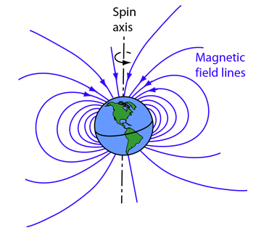

(Hyperphysics, 2019)

Name:
Proposed timeline

Wk | # | Topic | PowerPoint | STAWA Questions | Pearson Physics
9 | 1 | Electric fields | 1-10
9 | 2 | Coulomb’s Law | 11-14
9 | 3 | Electric Field Strength | 15-26
9 | 4 | Electric Potential | 27-31
9 | 5 | Magnetism | 32-41
10 | 1 | Magnetic flux | 32-41
10 | 2 | Earth’s magnetic field | 42-44
10 | 3 | Electromagnetism | 45-52
10 | 4 | 3D field diagrams | 45-52
10 | 5 | Good Friday
1 | 1 | ANZAC Day
1 | 2 | Magnetic field from a current | 45-52
1 | 3 | Solenoids | 53-57
1 | 4 | Solenoid applications | 58-61
1 | 5 | Force on a current in a magnetic field | 62-76
2 | 1 | Motors | 62-78
2 | 2 | Deflection of a charged particle by a magnetic field | 79-84
2 | 3 | Arts Cup/Interhouse Cross Country
2 | 4 | Task 5: Motors and electromagnetic force validation
2 | 5 | Induction | 85-94
3 | 1 | Induced emf in a coil | 85-94
3 | 2 | Generators | 95-99
3 | 3 | Back emf and counter torque | 100-101
3 | 4 | Transformers | 102-106
3 | 5 | Power transmission | 107-109
4 | 1 | Other applications of induction | 110-117
4 | 2 | Revision
4 | 3 | Revision
4 | 4 | Task 6: Electromagnetism Topic Test
4 | 5 | Exam Revision
5 | 1-5 | Exam revision
6 | 1-5 | Exams
7 | 1-5 | Exams

SCSA ATAR Syllabus
https://senior-secondary.scsa.wa.edu.au/syllabus-and-support-materials/science/physics

Science Understanding
- electrostatically charged objects exert a force upon one another; the magnitude of this force can be calculated using Coulomb’s Law
This includes applying the relationship
$$F=\frac{1}{4πε_{0}}\frac{q_{1}q_{2}}{r^{2}}$$
- point charges and charged objects produce an electric field in the space that surrounds them; field theory attributes the electrostatic force on a point charge or charged body to the presence of an electric field
- a positively charged body placed in an electric field will experience a force in the direction of the field; the strength of the electric field is defined as the force per unit charge
This includes applying the relationship
$$E=\frac{F}{q}=\frac{V}{d}$$
- when a charged body moves or is moved from one point to another in an electric field and its potential energy changes, work is done on the charge by the field
This includes applying the relationship
$$V=\frac{W}{q}$$
- the direction of conventional current is that in which the flow of positive charges takes place, while the electron flow is in the opposite direction
- current-carrying wires are surrounded by magnetic fields; these fields are utilised in solenoids and electromagnets
- the strength of the magnetic field produced by a current is a measure of the magnetic flux density
This includes applying the relationship
$$B=\frac{μ_{0}}{2π}\frac{I}{r}$$
- magnets, magnetic materials, moving charges and current-carrying wires experience a force in a magnetic field when they cut flux lines; this force is utilised in DC electric motors and particle accelerators
This includes applying the relationships
$$F=qvB where v⊥B, F=IlB where l⊥B$$
- the force due to a current in a magnetic field in a DC electric motor produces a torque on the coil in the motor
This includes applying the relationship
$$τ=r_{⊥}F$$
- an induced emf is produced by the relative motion of a straight conductor in a magnetic field when the conductor cuts flux lines
This includes applying the relationship
$$induced emf=lvB where v⊥B$$
- magnetic flux is defined in terms of magnetic flux density and area
This includes applying the relationship
$$ϕ=BA_{⊥}$$
- a changing magnetic flux induces a potential difference; this process of electromagnetic induction is used in step-up and step-down transformers, DC and AC generators
This includes applying the relationships
$$induced emf=-N\frac{\left(Φ2-Φ1\right)}{t}=-N\frac{Δϕ}{t}=-N\frac{Δ(BA_{⊥})}{t}$$
$$AC generator emfmax=2NlvB=2πNBA_{⊥}f, emfrms=\frac{emfmax}{\sqrt{2}}$$
$$\frac{V_{p}}{V_{s}}=\frac{N_{p}}{N_{s}}$$
$$P=VI=I^{2}R=\frac{V^{2}}{R}$$
- conservation of energy, expressed as Lenz’s Law of electromagnetic induction, is used to determine the direction of induced current

Science as a Human Endeavour
Electromagnetism is utilised in a range of technological applications, including:
DC electric motor with commutator, and back emf; AC and DC generators; transformers; regenerative braking; induction hotplates; large scale AC power distribution systems

Electric fields
- A region in space in which charged particles experience a force
- Direction of field is the direction that a positive charge would be pushed

Drawing electric field lines
- Field lines start and end on charges
- Field lines must not cross
- Field lines at the surface of a charged object must be perpendicular to the surface
- Density of field lines shows strength of field

Draw field diagrams for each of the following situations:
Positive point charge

Two like point charges

Two unlike point charges

Parallel plates

Parallel plates and point charge

3 point charges

Line of equipotential
- Show lines of equal electric potential – similar to contour lines on a map
- Typically drawn as dashed lines to contrast with the solid field lines
- Lines of equipotential must be perpendicular to field lines
- Field strength equals the gradient of electric potential – the closer the lines of equipotential are the higher the field strength

Add dashed lines of equipotential to previous field diagrams

Coulomb’s Law
- Force of attraction OR repulsion between two charged objects

$$F=k\frac{q_{1}q_{2}}{r^{2}}=\frac{1}{4πε_{0}}\frac{q_{1}q_{2}}{r^{2}}$$

$$k=Coulomb's constant (9×{10}^{9} N m^{2} C^{-2})$$
$$q=charges of the two objects \left(C\right)$$
$$r=distance between the two objects \left(m\right)$$

- Note that this follows an inverse square law

Example 1
- Calculate the size of the force between a proton and an electron in a H-1 atom. Assume they are 8x10⁻¹¹ m apart.

Inverse Square recap
Can use:
$$F_{1}r_{1}^{2}=F_{2}r_{2}^{2}$$

By what factor does the force between two charged particles change if the charge of one particle halves and the distance between the two quarters?

Electric Field Strength (E)
- The force per unit (positive) charge at a point in an electric field (N C⁻¹)
- It is a vector

$$E=\frac{F}{q}$$

$$E=Electric field strength \left(N C^{-1}\right)$$
$$F=Force \left(N\right)$$
$$q=charge (C)$$

Recall that:
$$F=k\frac{q_{1}q_{2}}{r^{2}}=\frac{1}{4πε_{0}}\frac{q_{1}q_{2}}{r^{2}}$$
So:
$$E=k\frac{q}{r^{2}}=\frac{1}{4πε_{0}}\frac{q}{r^{2}}$$

Examples
- Calculate the field strength due to a proton at a distance of 8x10⁻¹¹ m.

- A point charge of 3.2 mC experiences a force of 4.58 x 10⁻³ N when placed in an electric field. Determine the field strength at that point.

Electric field strength from potential difference
- For a uniform electric field caused by a potential difference (voltage), e.g. between parallel charged plates:
$$E=\frac{V}{d}$$

$$E=electric field strength (N C^{-1} OR Vm^{-1})$$
$$V=potential difference between plates \left(V\right)$$
$$d=distance between plates (m)$$

+++++++++++++++++++++++++++
------------------------------------------------------
V

Two parallel plates are 10 cm apart with a potential difference of 120 V. Determine:
- The field strength directly between the two plates.
- The force on a proton at this point.
- The force on an electron at this point.

A bubble of mass m, charge +q and initial velocity u moves between charged plates. The bubble is initially traveling parallel to the plates. Find the acceleration of the bubble ignoring gravity.

Write an expression relating the position of the bubble to time. Consider components.

A bubble of mass m, charge +q and initial velocity u moves between charged plates. The bubble is initially traveling perpendicular to the plates. Find the acceleration of the bubble ignoring gravity.

Write an expression relating the position of the bubble to time. Consider components.

Cathode rays
- Discovered that electricity could pass through a vacuum at high enough voltage – had to be something carrying the current – cathode rays
- If phosphor was placed along the path of the current through the vacuum it would light up
- Turned out to be a beam of electrons that excite the phosphor as they pass by

Cathode ray tube
- Cathode ray beam controlled by two sets of charged plates - one to control x position, one for y

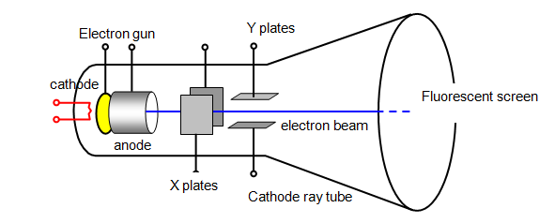
Milikan’s Oil Drop Experiment
- Drops of oil charged by x-rays
- Electric field adjusted until drops would sit suspended above the charged plate
- From size of drop and strength of electric field to suspend it the charge of the drop could be determined
- All values of charge turned out to be integer multiples of a certain number – the charge of a single electron
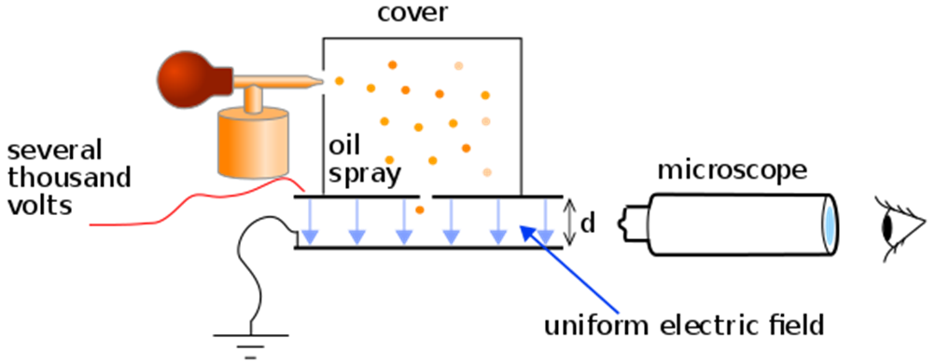

Electric potential (V)
- Electric potential energy per unit charge (J C⁻¹ or V)
- This is the work that must be done per unit charge to bring a positive charge from infinity to the point.
$$V=\frac{W}{q}$$
$$V=electric potential \left(V\right)$$
$$W=work \left(J\right)$$
$$q=charge (C)$$
Given on the datasheet as:
$$W=Vq$$

Electric potential difference (V)
- Difference in potential energy between two points in an electric field
- Commonly referred to as voltage
- If a charged object is moved through an electric field, work is done, the work is equal to the change in energy
- If an object is pushed against the field the work done is the gain in potential energy
- If an object moves with the field the work done is the gain in kinetic energy
$$W=qV=E_{K}=\frac{1}{2}mv^{2}$$

Work from electric potential difference analogous to work from vertical movement
- An object lifted off the ground will gain gravitational potential energy  $$W=∆E=mgh$$  - If released it will fall towards the ground converting the gravitational potential energy to kinetic energy  $$KE=W=∆E$$ | - A positively charged object pulled away from a negatively charged object will gain electric potential energy  $$W=∆E=∆Vq$$  - If released it will ‘fall’ towards the negatively charged object converting the electric potential energy to kinetic energy  $$KE=W=∆E$$

Examples
Two parallel charged plates 15 cm apart create an electric field of 2.4 kN C⁻¹. Determine:
- Potential difference between the plates.
- The gain in kinetic energy if an electron moves from the negative to the positive plate.
- The final velocity of the electron if it was initially stationary.

A proton is accelerated between two parallel plates 50 mm apart, with an electric field strength of 2.4x10³ N C⁻¹, what is the final velocity of the proton assuming it is initially stationary?

Magnets
- Objects which exert a force on nearby magnets, iron, cobalt or nickel
- Exerts a force at a distance by creating a magnetic field
- Can be thought of as having two opposing poles, referred to as North and South because they will align with the Earth’s magnetic field if allowed to float freely (e.g. in a compass)
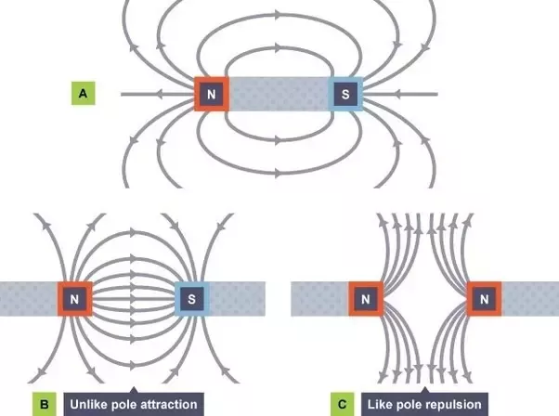
https://qph.fs.quoracdn.net/main-qimg-b16f909d05c4d86d7fc69c976e9740f8.webp
Law of poles
- Opposite poles attract
- Like poles repel

Magnetic fields
- A region of space around a magnet
in which another magnet, iron, cobalt
or nickel will experience a force
- Essentially caused by moving electric
charges

Magnetic field lines
- Similar to electric field lines
- Lines cannot cross
- Density of lines represents strength of magnetic field
- Arrow shows the direction a north pole would point (direction a compass would point)

Permanent magnet
- A magnet typically made of iron, cobalt and/or nickel
- Retains its magnetic behaviour for a long period of time without any input

Permanent magnets are essentially magnetic because they are made of many tiny magnets which are made of tinier magnets which are made of even tinier magnets, all aligned in the same direction, so that they don’t cancel each other out

- Magnets are magnetic because they are made of aligned magnetic domains (groups of atoms)
- Domains can be magnetic if they are made of aligned magnetic atoms
- Magnetic atoms can be magnetic because electrons are intrinsically magnetic

For a given substance to be magnetic the tiny magnets it is made of must align at all these different levels and not cancel each other out, this is rare, so only certain materials are magnetic
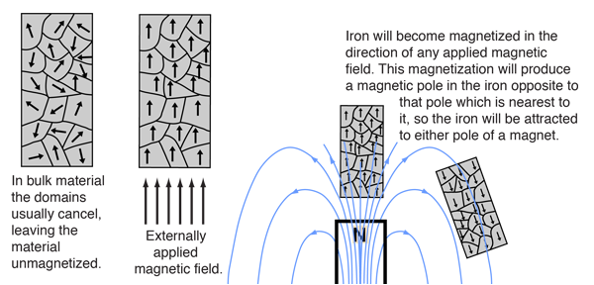
http://hyperphysics.phy-astr.gsu.edu/hbase/Solids/ferro.html

Electromagnet
- Magnet created by an electric current
- Can be turned on and off
- Variable strength dependent on current
- Reversible depending on direction of current
- Soft iron core (pure iron) – magnetized only when in magnetic field.

Magnetic flux density (B)
- Measures the strength of a magnetic field in an area, can be though of as the density of field lines
- Is a vector
- Units are ‘webers per square meter’ (Wb m⁻²) or Teslas (T)

Magnetic flux (φ)
- Measures the total magnetic field an object is exposed to, can be thought of as the total number of field lines passing through an object
- Is a vector
- Measured in webers (Wb)
$$\text{ϕ}\text{=B}A_{⊥} or \text{ϕ}\text{=BA}\sin{θ}$$

$$\text{ϕ}\text{ = magnetic flux (Wb)}$$
$$\text{B = magnetic flux density (T)}$$
$$\text{A = area }\left(m^{2}\right)$$
$$θ=angle between surface and direction of magnetic field (°)$$

Example
- Find magnetic flux density in an area of 0.44 m² where the flux is 0.075 Wb

Earth’s magnetic field – magnetosphere
- Thought to be caused by convection in the Earth’s molten metal core
- South magnetic pole very close to north geographic pole – angle of declination between the two
- The Earth’s magnetic field is not consistently parallel to the surface
- Close to the equator the field is parallel to the surface
- At the magnetic poles the angle of dip is 90°
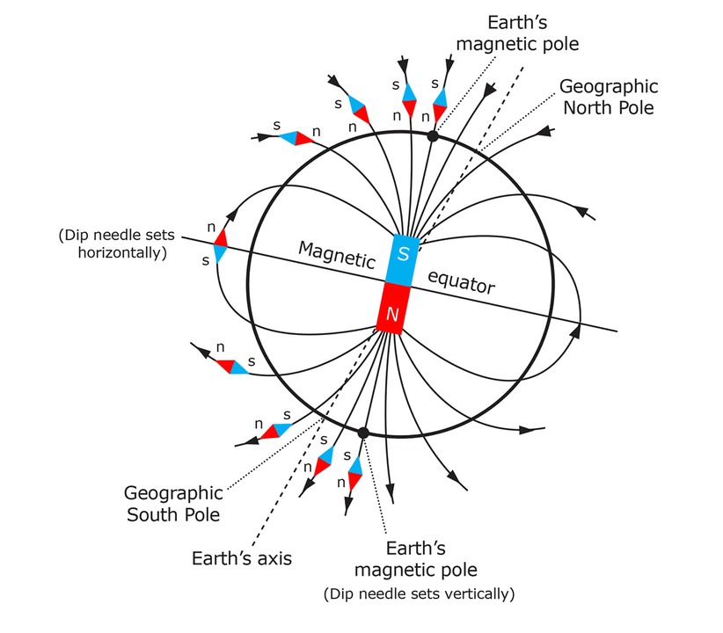
https://static.sciencelearn.org.nz/images/images/000/001/820/full/_DTP_ART_FossilCompasses_Earth%E2%80%99sMagneticField.jpg?1522303792

Components of magnetic field
Often necessary to find a component of the Earth’s magnetic field, typically the components parallel or perpendicular to the Earth’s surface. Use trigonometry as you would to find components in any other situation.

At a point on the Earth’s surface the magnetic field is 0.050 mT at an angle of 20° to the horizontal, find the vertical and horizontal components of the field.

Electromagnetism
- In 1820 Hans Christian Ørsted discovered that a wire carrying a current caused a magnet to deflect
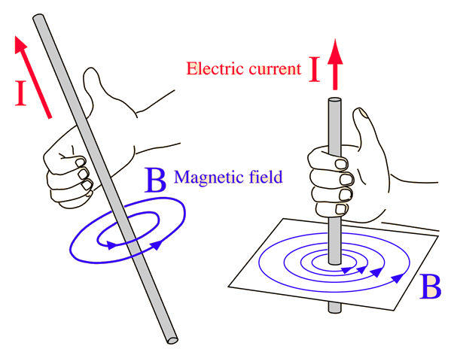
- Electricity and magnetism are inherently connected, they are collectively referred to as electromagnetism

Magnetic field from electric current
- Current flowing along a conductor creates a
magnetic field around the conductor
- Right hand grip rule: with thumb pointing the
direction of conventional current, the curled
fingers show the direction of the magnetic field
- Magnetic field strength is propotional to the
current and inversely proportional to distance
from the conductor

3D field diagrams on 2D paper
- Field lines can be shown heading into or out of the page
- Think of a fletched arrow, the point is heading towards you, the fletching is heading away from you

Into page Out of page

Show the direction of the magnetic field lines around the wires below.

Magnetic field strength from a wire
$$B=\frac{μ_{0}I}{2πr}$$

$$B=magnetic flux density (T)$$
$$μ_{0}=magnetic constant=4π×{10}^{-7} N A^{-2}$$
$$I=current \left(A\right)$$
$$r=distance from wire (m)$$

Complete the table below and graph the data on the axes below

Distance (cm) | Magnetic field strength (T)
10
20
40
60
80
100

Current flowing in a loop
- Show the direction of the magnetic field all around the loop

- Draw the magnetic field line are around the wires.

Solenoids
- An electromagnet made of many loops of wire
- Create a strong uniform magnetic field inside the loops
- External magnetic field like that of a bar magnet
- Right hand grip – with thumb to the north pole, curled fingers show conventional current
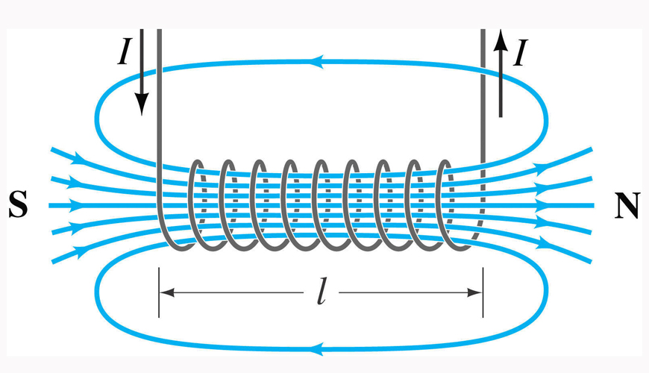
http://www.justscience.in/wp-content/uploads/2017/05/HOW-DOES-A-SOLENOID-WORK.jpg

Remembering solenoid direction
- If viewed from the end, if current is flowing anti-clockwise it is the north pole, if current is flowing clockwise it is the south pole

Solenoid electromagnet
- A solenoid electromagnet placed over a soft iron core makes a good electromagnet
- The soft iron forms a temporary magnet, enhancing the magnetic field while the solenoid is on but losing its magnetic field when it is turned off
- Magnet strength depends on current and number of coils
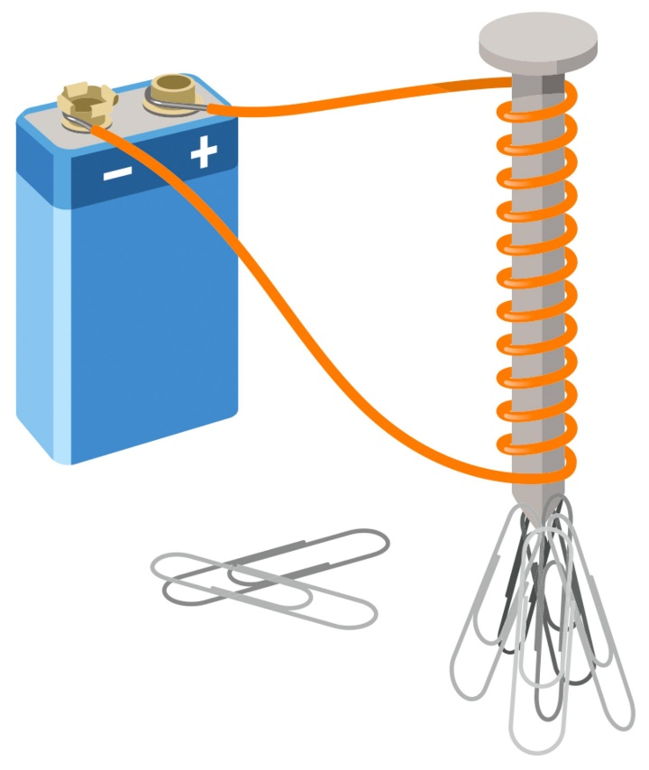
https://res.cloudinary.com/dk-find-out/image/upload/q_80,w_1920,f_auto/DK_aw_Solenoid_FINAL_k4bmdo.jpg

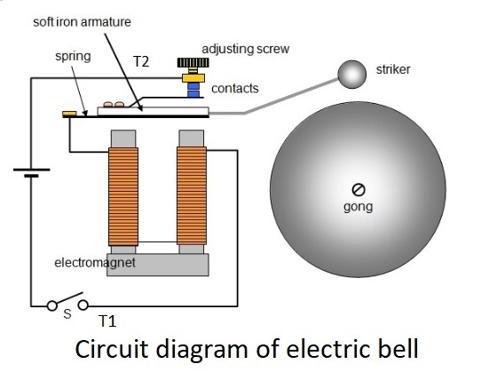
Solenoid applications - Bell
https://onlinesciencenotes.com/wp-content/uploads/2019/02/bells.jpg
- When circuit switched on the armature is pulled towards the electromagnet causing the striker to hit the bell but also breaking the circuit
- The spring causes the armature to return to position completing the circuit, this repeats as long as the circuit is on

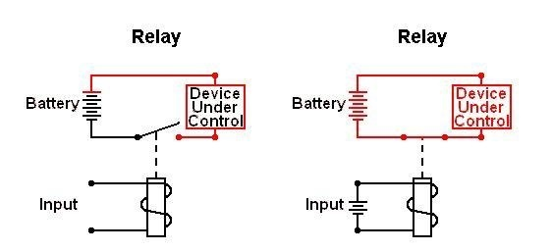

Solenoid applications – Relay
- Electromagnet in one circuit used to throw switch in another circuit
- Allows low voltage circuit to control high voltage circuit (electrically isolated)
- One relay can control multiple other switches

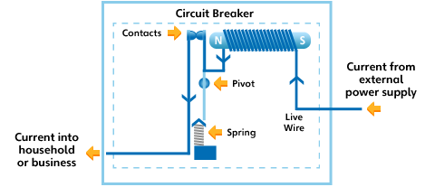

Solenoid applications – Circuit breaker
- Solenoid in line of circuit
- If current becomes too high the solenoid becomes strong enough to break the circuit

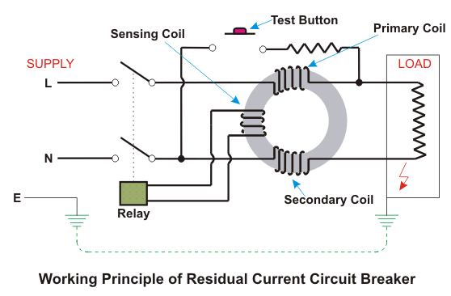
Solenoid applications – Residual current
- 2 coils powered by the active and the neutral wires attempt to establish opposite electromagnets
- If current in one wire is greater than the other it ‘wins’
- Triggers a relay to cut the circuit

Field diagrams practice
- Determine the direction of the magnetic field next to current carrying wires at point a in the diagrams below
a) b) c) d) e)
a
a

a
a
a

- Determine the direction of the current in the wires below. (Magnetic field shown in grey.)
a) b) c) d) e)

- Determine the direction of the magnetic field at points a, b, c, and d near the wires shown below.
a
b
c
d
a
b
c
d
Force on a current in a magnetic field
- A wire carrying a current through a magnetic field can experience a force
- Maximum force is when the current and field are perpendicular, the resulting force is perpendicular to both the current and the field
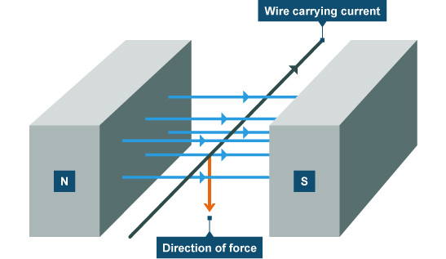
https://i.stack.imgur.com/pgZJc.jpg

Right hand slap rule
- If you align your thumb with the current, and your fingers with the magnetic field, then your palm faces the direction of the force

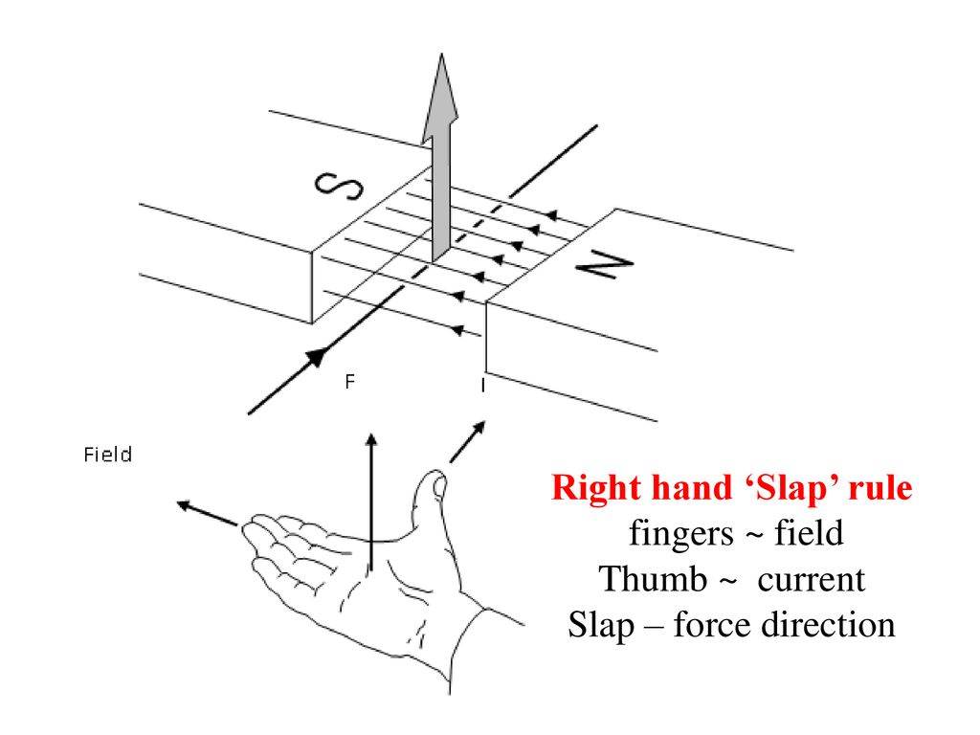
https://slideplayer.com/slide/15151330/91/images/3/Right+hand+%E2%80%98Slap%E2%80%99+rule+fingers+~+field+Thumb+~+current+Slap+%E2%80%93+force+direction.jpg

Calculating force on a wire in a magnetic field

$$F=IlB_{⊥} or F=IlB\sin{θ}$$

$$F=force \left(N\right)$$
$$I=current \left(A\right)$$
$$l=length of wire \left(m\right)$$
$$B_{⊥}=magnetic field strength \left(T\right)$$
$$θ=angle between direction of magnetic field and wire (°)$$

Determine the magnitude of the force due to the Earth’s magnetic field, on 1m of a suspended power line running east west and carrying a current of 100 A if the magnetic field strength at that location is 5 x10⁻⁵ T.

Determine the magnitude of the force due to the Earth’s magnetic field, on 1m of a suspended power line running north south and carrying a current of 100 A if the magnetic field strength at that location is 5 x10⁻⁵ T and the dip angle is 40°.

Explanation for force on a wire using field lines
- Recall that field lines will not cross, can’t have two lines heading in opposite directions next to each other

N
S
N
S

N
S
N
S

Force diagrams practice
Indicate the direction of the force on the wire in the diagrams below. The magnetic field is shown in grey.

Force between two parallel wires
- Two current carrying wires running parallel will exert a force on each other
- If the current is in the same direction in both wires they will attract each other
- If the current is in opposite directions they will repel each other (B density)
- Calculate magnitude of force by combining previous formulae

$$B=\frac{μ_{0}I}{2πr} and F=IlB_{⊥}$$
$$F=\frac{μ_{0}I_{1}I_{2}l}{2πr}$$

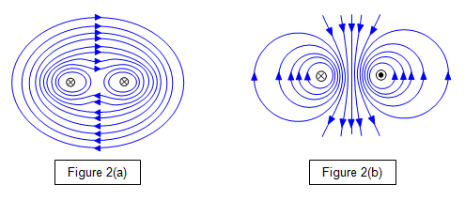
http://www.schoolphysics.co.uk/age16-19/Electricity%20and%20magnetism/Electromagnetism/text/Forces_between_currents/index.html

Motor basics
- Coil of N loops placed between two magnets
- Each side of the coil experiences a force in opposite directions when current flows through the coil – causes torque - causes rotation
- Commutator flips direction of current in the coil twice every rotation maintaining constant direction of rotation
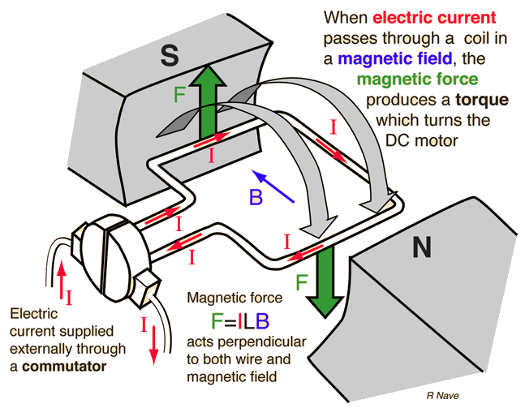

Split-ring commutator
- Allows direction of current in coil to flip in sync with the rotation of the coil

Determining maximum torque on a coil
- Force on one side of the coil:

$$F=NIBl$$
- Torque supplied by coil:

$$τ=2rF so τ=2rNIBl$$
$$2rl=A so:$$

$$τ=NAIB$$

$$τ=torque \left(N m\right)$$
$$r=distance from axis of rotation to edge of coil \left(m\right)$$
$$A=area of the coil (m^{2})$$

A DC motor made of a 6 cm square coil with 300 turns. If the current through the coil is 2 A and the magnetic field is 0.55 T determine:
- The size of the force on one edge of the coil.
- The torque on the coil.
- Sketch a torque/time graph for 1 cycle if f=10 Hz and it starts at F_{max}

Simple motor problems
- When the coil sits at a right angle to the field lines the torque on the coil is zero, only keeps turning due to inertia – jerky motion

Motor improvements
- Multiple coils each attached to their own commutators to create smoother more consistent torque
- Curved electromagnets (stator) to maximise torque
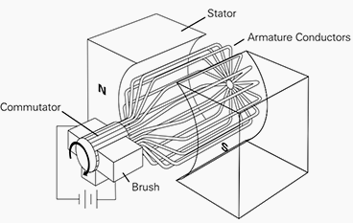

AC motor
- Instead of split ring commutator with DC can use 2 slip-ring system with AC
- Current changes direction at correct frequency to maintain constant direction of torque
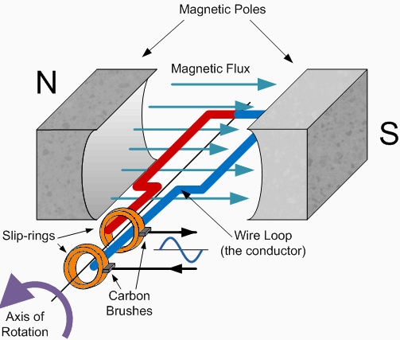

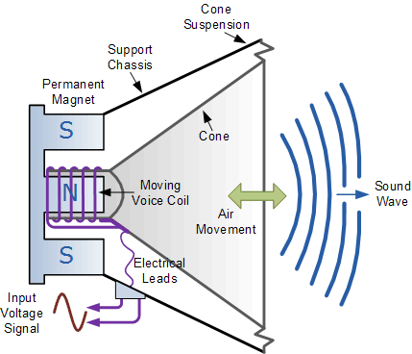
Speakers
- Coil which can slide back and forth over the central pole of a circular permanent magnet
- Alternating current through coil makes the coil vibrate the frequency of the AC
- Vibrating coil vibrate cone which transfers the energy to the air as sound waves

Ammeters
- DC flows through coil – causes coil to experience torque related to current
- Coil rotates against a spring until spring torque = magnetic torque
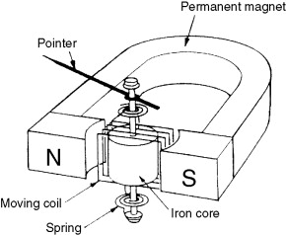

Deflection of a charged particle by a magnetic field

- Recall mass spectrometers
$$F=qvB_{⊥}$$

$$F=force \left(N\right)$$
$$q=charge \left(C\right)$$
$$v=velocity \left(m s^{-1}\right)$$
$$B_{⊥}=magnetic field strength perpendicular to velocity (T)$$

Note: still use right hand slap to determine direction as you would for the force on a wire

- Force is always perpendicular to the direction of movement – circular movement
- Does the image of a charged particle entering a magnetic field show the path of a positive particle or a negative particle?

- Charged particles follow a path that is an arc of a circle of radius r
$$F=qvb=\frac{mv^{2}}{r}$$
$$r=\frac{mv}{Bq}$$

An electron is accelerated between two charged plates (32 kV) through a distance of 30 cm. The electron is then fired into a 0.2 T magnetic field perpendicular to the field.
- Find the electric field strength acting on the electron.
- Find the electrons velocity as it leaves the plates.
- Find the radius of the electron’s path.

Cyclotron
- Particle accelerator – creates focused beam of high energy particles
- Smaller and often cheaper than equivalent linear particle acclerators
- Range in size from 8 cm to 17 m in diameter
- Can be used to make radioisotopes for nuclear medicine e.g. Tc-99m
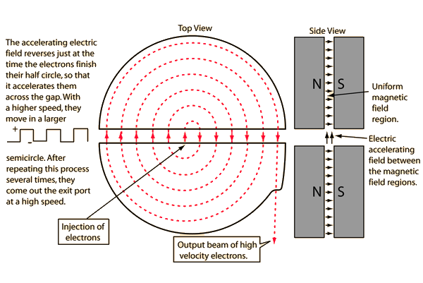

$$Bqv=\frac{mv^{2}}{r}$$
$$Bq=\frac{mv}{r}$$
$$v=\frac{2πr}{T}=2πrf$$
$$Bq=\frac{2πfrm}{r}$$
$$f=\frac{Bq}{2πm}$$

The frequency is independent of both radius and velocity so frequency can remain constant for the whole path of the particle

Induction
Faraday realised that if a current can cause a magnetic field then a magnetic field should be able to cause electric current
A current can be induced by:
- Moving a magnet in or out of a coil
- Switching an electromagnet on or off
- Moving the coil in a magnetic field
- An electromagnet connected to AC
Essentially you need relative motion between a conductor and a magnetic field

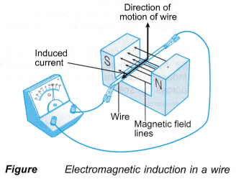
Induced emf across a straight moving conductor

$$ε=lvB_{⊥}$$

$$ε=induced electromotive force \left(V\right)$$
$$l=length of conductor \left(m\right)$$
$$v=velocity of conductor \left(m s^{-1}\right)$$
$$B_{⊥}=magnetic field strength perpendicular to velocity (T)$$

- Induced EMF is a result of separation of charge in a conductor
- Consider electrons in a metal bar moving through a magnetic field
- Each will experience a force as a charged particle moving through a magnetic field
- They can be pushed towards one end of the conductor
- Protons would also experience a force in the opposite direction but are unable to move
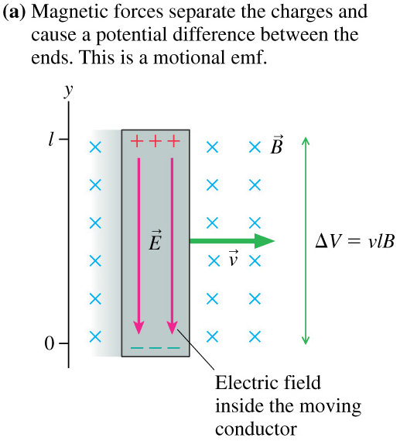

An airplane flies through the Earth’s magnetic field.
- At which points will the induced emf be a maximum and at which will it be a minimum?
- If it has a wingspan of 64 m and is flying at 990 km h⁻¹ through a magnetic field of
60 μT, determine the maximum emf that could be induced across the wings.

Induced emf in coils – Lenz’s law – conservation of energy
- An induced emf can establish a current
- Such a current sets up a magnetic field which acts to oppose the change in magnetic flux
- The result is a force opposing the movement
- Electrical energy is not created from nowhere, the kinetic energy of the movement is converted to the electrical energy

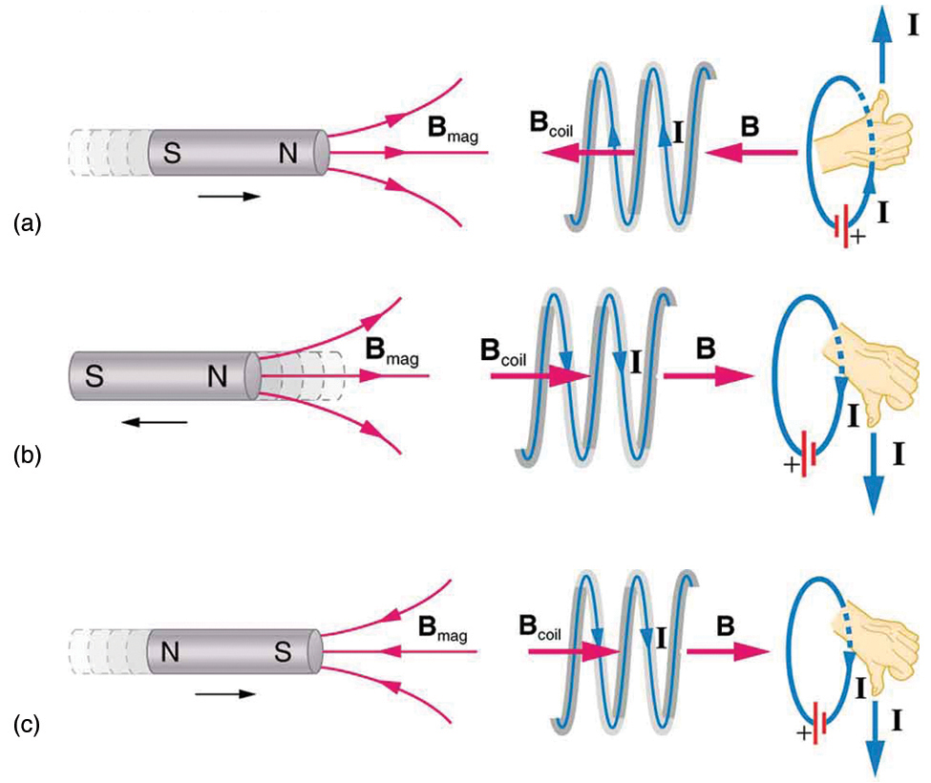
(Average) Induced emf in coils – Faraday’s law

The induced emf in a coil is directly proportional to the rate of change of magnetic flux cutting the coil
$$ε=-N\frac{∆Φ}{t}=-N\frac{∆\left(BA_{⊥}\right)}{t}$$

$$ε=induced electromotive force \left(V\right)$$
$$N=number of turns in the coil$$
$$Φ=magnetic flux \left(Wb\right)$$
$$t=time \left(s\right)$$
$$B=magnetic field strength \left(flux density\right)\left(T\right)$$
$$A_{⊥}=area of coil perpendicular to magnetic field (m^{2})$$

A student places a horizontal 5 cm square coil into an upwards vertical 0.1 T magnetic field
- How much flux cuts the coil?
- Determine the emf and direction of current in the coil if it is pulled out of the field in
1 s
- Determine the emf and direction of current in the coil if it is pushed back in in 0.5 s

A student places a horizontal 5 cm square coil into an upwards vertical 0.1 T magnetic field. Describe the current in the coil if the student rotates the coil 360° in 2 s.

A 40 cm², 20 turn coil is placed horizontally in a 0.1 T vertical magnetic field. The coil is connected to a galvanometer (≈ analogue ammeter) with a resistance of 200 Ω.
- How much flux passes through the coil?
- If the coil is withdrawn in 0.5 s, what current flows through it?

ATAR 2019:
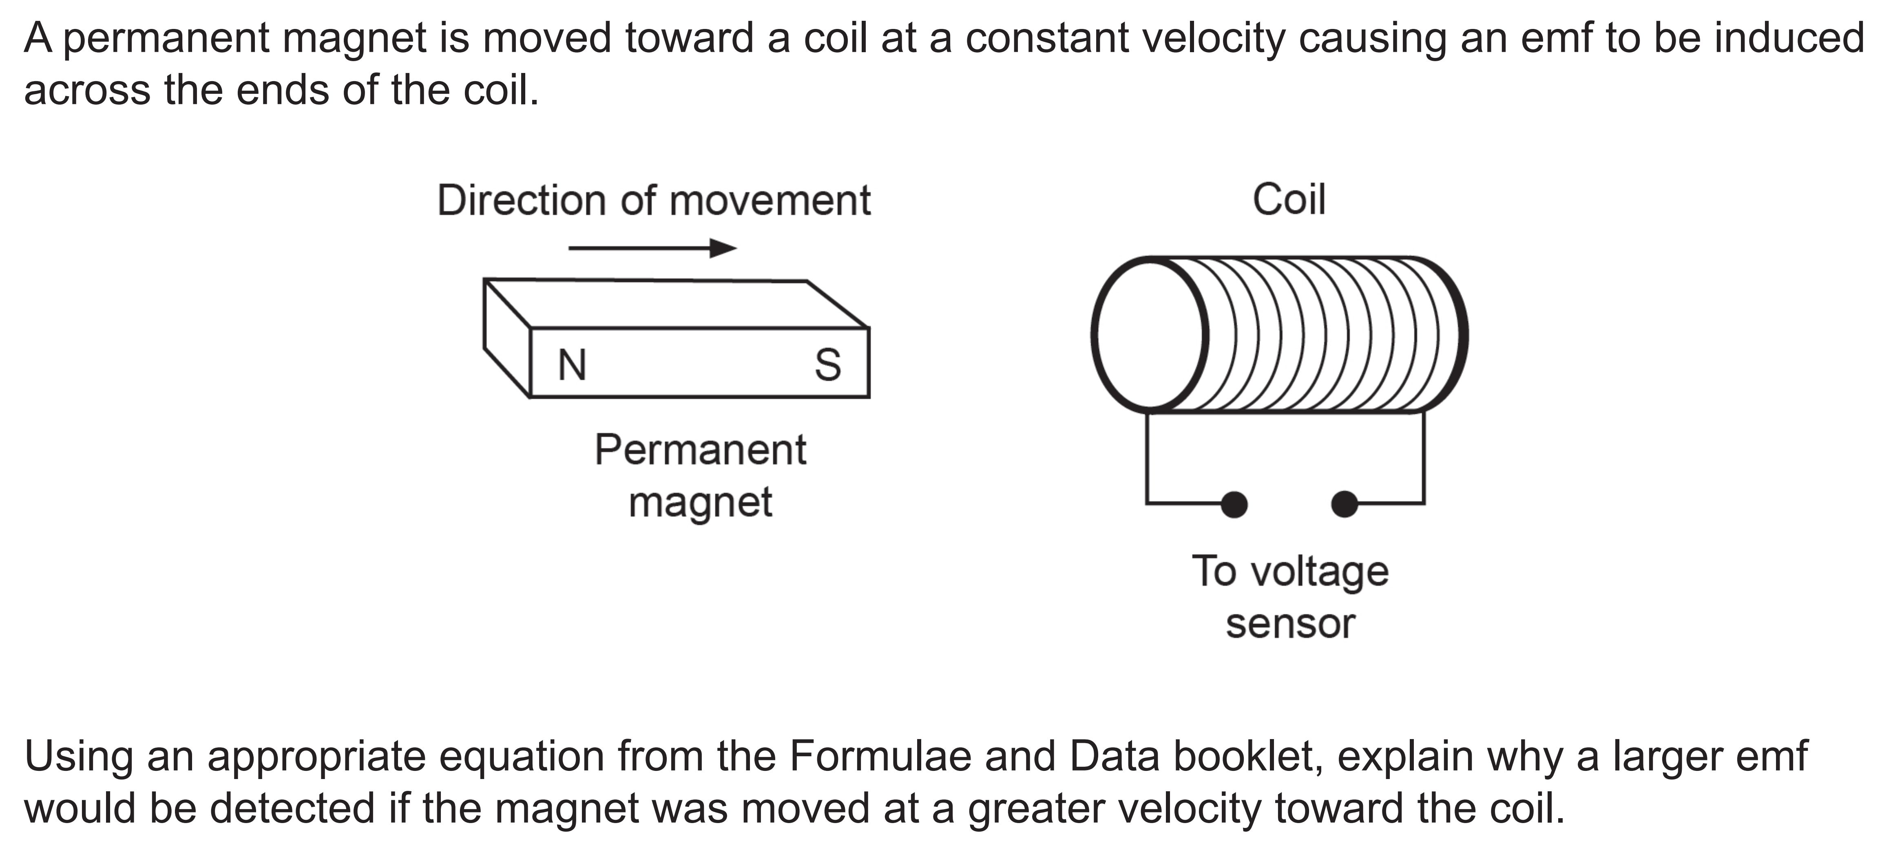

PLEASE TAKE NOTE OF DETAIL GIVEN IN MARKING KEY.

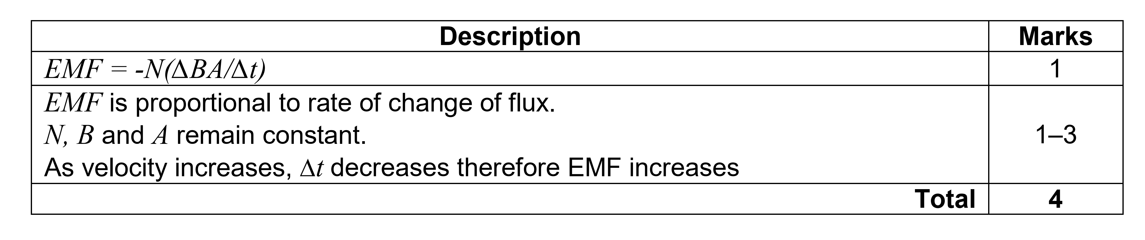
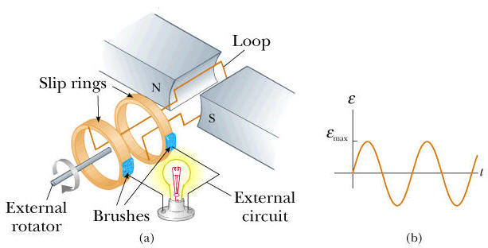
Generators
- Make use of induction to create a useful electric current
- Need a coil moving relative to a magnetic field
- Simple to create AC, can also create DC with split ring commutator

A generator with a 100 turn, 30x12 cm coil rotates in a 0.2 T magnetic field with a frequency of 2 Hz. Determine the average emf induced in the coil.

Root mean square emf
- For alternating current, the RMS is equal to the value of the direct current that would produce the same average power in a circuit.

$$ε_{rms}=\frac{ε_{max}}{\sqrt{2}}$$

- To find the RMS emf you need the maximum emf

$$ε_{max}=2NlvB=2πNBA_{⊥}f$$

A 10 cm square coil of 400 turns is rotated at 25 Hz in a magnetic field of 0.1 T.
- Find the maximum induced emf.
- Assuming maximum flux is at t = 0 s sketch the emf as a function of time for 0.12 s

A 40 turn 15x25 cm coil is rotating at 1500 rpm in a 0.35 T magnetic field.
- Determine the max emf produced by the coil.
- Determine the RMS voltage produced.
- Determine the peak voltage if the frequency is doubled.

DC generator
- Split ring commutator to flip direction of emf/current
- Split ring commutator can introduce problems; wear on brushes, sparking as it crosses
- Not a smooth emf/current
- Add multiple coils to smooth out

Back emf
- Generators and motors are virtually the same machine, once they are running, there are effectively both present
- An operating motor will act as a generator; inducing an emf that opposes the emf driving the motor
- Back emf is proportional to the angular velocity of the motor
- When a motor is fist turned on the velocity is low so the back emf is low so current is high allowing for maximum ability to do work; spin up to speed
- If a motor is kept on but jammed, unable to turn, current will remain high for a long time, potentially burning out the device
- If the motor is running smoothly the velocity will increase until back emf is almost equal to the driving emf so it will just draw enough current to overcome friction and turn at constant velocity
- If a load is applied to the motor, it effectively increases friction, decreasing velocity and therefore back emf, so current increases allowing for more work to be done

Counter torque
- Generators and motors are virtually the same machine, once they are running, there are effectively both present
- An operating generator will act as a motor; creating a torque that opposes the driving torque on the generator
- Counter torque is proportional to the current in the coil
- A turning generator with no load has an emf but no current so there is no counter torque
- Once the circuit is completed, including a load, the current will flow causing counter torque, increasing the driving torque needed to turn the generator at a given frequency
- If the driving torque is kept constant the back torque will vary until it and friction balance the driving torque resulting in a constant speed of rotation
Transformers
- Device for increasing or decreasing AC voltage
- Requires two coils, changing flux produced by the first coil induces emf in the second coil
- Iron core ensures all flux from first coil passes through second

$$\frac{Vp}{Vs}=\frac{Np}{Ns}$$
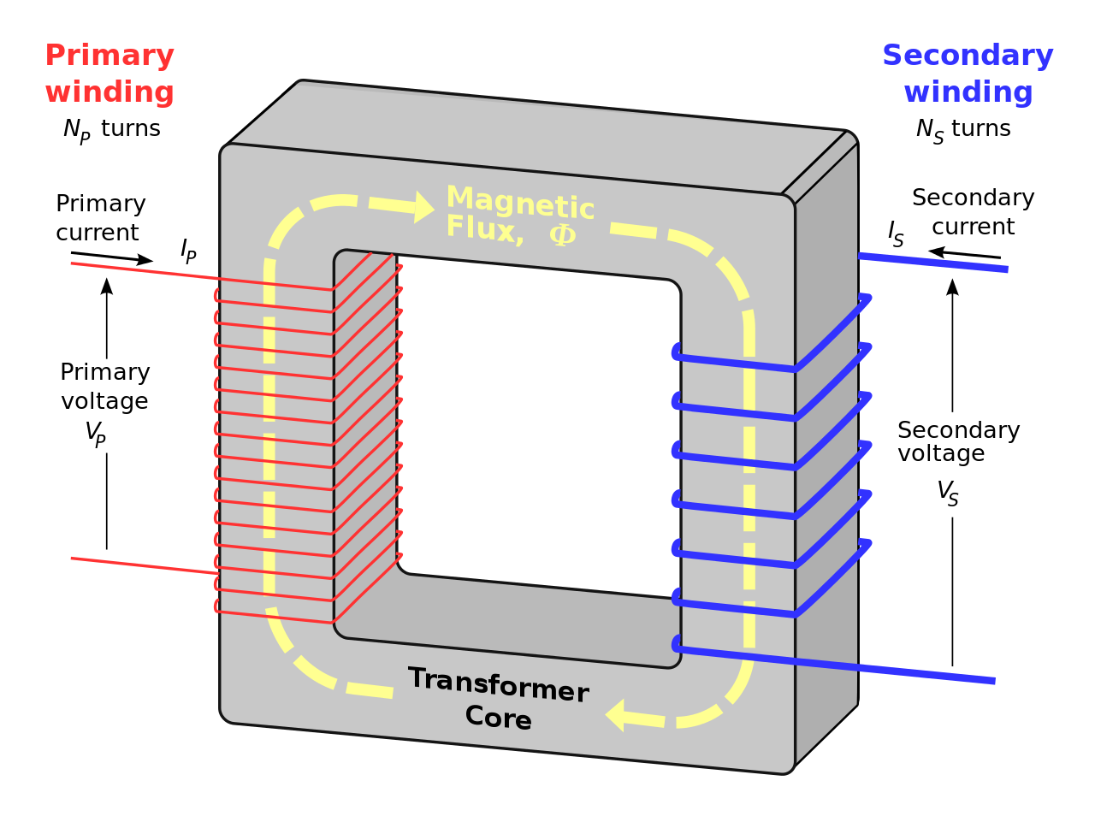
https://upload.wikimedia.org/wikipedia/en/thumb/e/e7/Transformer3d_col.svg/1280px-Transformer3d_col.svg.png

- Step-up transformer: increases voltage – more turns in secondary coil
- Step-down transformer: decreases voltage – fewer turns in secondary coil
- Iron core laminated: made of thin insulated sheets to reduce eddy currents and therefore energy loss as heat – increases efficiency
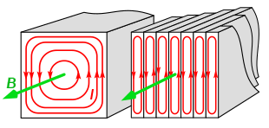
- While voltage is transformed, power remains constant (assuming 100% efficiency)
https://upload.wikimedia.org/wikipedia/commons/thumb/e/ea/Laminated_core_eddy_currents_2.svg/620px-Laminated_core_eddy_currents_2.svg.png

A model train transformer outputs at 12V.
- If the secondary coil has 100 turns, how many does the primary coil have?
- If the train requires 4 A, what current and power is drawn from the mains?

A 120 W, 24 V AC supply is connected to the input of a transformer. The primary coil has 240 turns. The output is 72 V.
- Find the number of turns in the secondary coil.
- Name the type of transformer.
- Determine the output current.

Transmission of power
- Power is generated at power plants and must be distributed across large distances
- Current travelling through a wire will lose power due to resistance converting the electrical energy to heat
$$P=VI but P_{loss}=I^{2}R$$
- Therefore if voltage is increased but current reduced the same power can be transmitted with less power loss – transmit power at extremely high voltages to minimise power loss
- transformers are key to our power transmission
- major advantage of AC – transformers easily step voltage up and down with AC

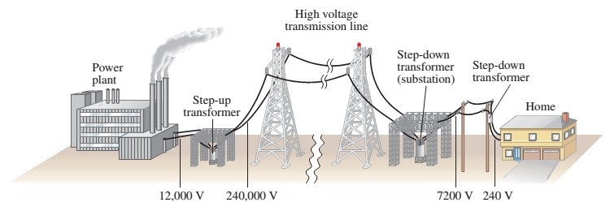

During peak demand, 635 MW is provided to Perth from Muja Power Station along a 2 Ω power line.
- What would be the power loss if the potential at Muja was 500 kV?
- Since the current will remain constant, what will the potential be at Perth?

A 20 kW, 400 V diesel generator supplies power for 400 V lights on a film set at an outside location. The 500 m transmission cable has a resistance of 5 Ω. If 2 transformers are used with 1:20 ratio in turns.
- What is the current in the cables?
- What is the voltage drop across transmission cables?
- What is the power loss in the cables as a percentage of power supplied by the generator?
- What voltage is supplied to lights?

An AC generator produces 10 kW of power to be transmitted at 240 V down a 5 km line of 1.5 Ω resistance.
- Determine the power loss in the line.
- Determine the voltage at the end of the line.

Other examples of induction

Magnet dropped, South side down, down copper tube
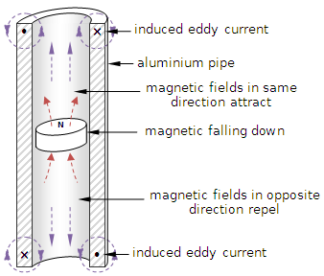
- As the magnet falls down, the tubing below it is experiencing an increase in upwards magnetic flux, this creates clockwise (from above) current in the tube to create an opposing magnetic field, this repels the magnet from below, slowing its fall
- The tubing above is experiencing a decrease in upwards magnetic flux so the current flows counter-clockwise (from above) to create an increase in upwards magnetic field, this attracts the magnet from above also slowing its descent
- The same occurs if the magnet is dropped north side down, just with all directions of field and current reversed
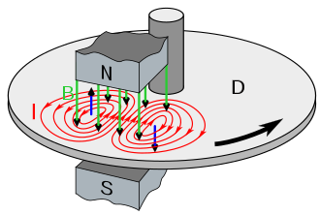
- Lenz’s law, the gravitational potential energy is converted not just to kinetic energy as the magnet falls, but also to electrical energy, as the total quantity of energy is conserved, the magnet must gain less velocity (kinetic energy) as it falls

Braking
- Regenerative braking; when braking the cars motor can behave as a generator, turning kinetic energy back into electrical energy
- Electromagnet brakes; electromagnets switched on in metal wheel disc, creates circular currents in the disc (eddy currents) which oppose the changing magnetic field, slowing the wheel

Eddy currents – crack detection
- Test coil brought near conductor, establishing eddy currents
- Physical defects in the conductor will weaken the eddy currents, weakening the magnetic field they establish so the presence of defects can be detected
Magnetic Field
From Test Coil
Magnetic Field From
Eddy Currents
Eddy Currents
Crack
- Can also be used for the measurement of the thickness of layers of conductive material – maintenance of aircraft wings, pipes etc. looking for corrosion or erosion of thin layers

Induction hot plate
- Electromagnet on AC in stove
- Sets up large eddy currents in the thick metal pot base, generating heat due to resistance

Eddy currents – metal detector
- Transmitting coil creates magnetic field which establish eddy currents in conductive materials – does not have to be magnetic
- Eddy currents establish magnetic field which is detected by receiver coil because it induces a current
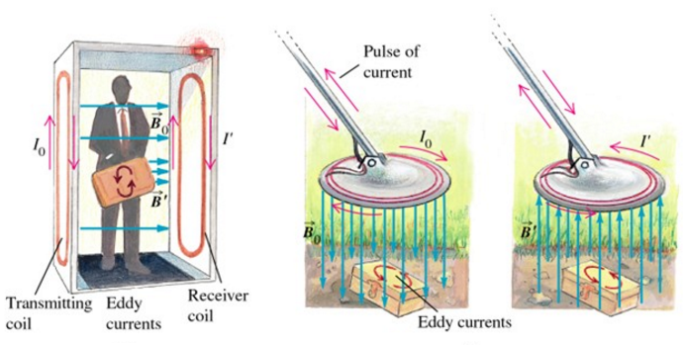
https://www.hardware-pro.com/wp-content/uploads/2016/10/Eddy-Currents-2-Hardware-Pro.bmp

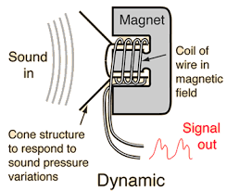
Moving coil microphone
- Same as a loudspeaker in reverse
- Sound waves vibrate cone at certain frequency causing coil to vibrate at the same frequency
- Relative motion induces current in the coil alternating at the same frequency as the sound waves
- Current passed on to computer for interpretation

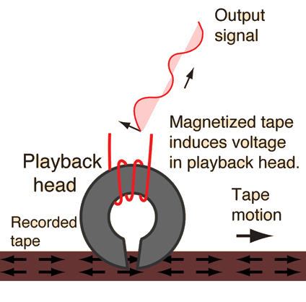
Magnetic tape – cassette tapes, VHS, credit card strip
- Thin tape containing microscopic magnetic particles
- Magnetic domains in the particles can be aligned in an organized manner to store information
- As the tape passes by the gap in the iron core, the flux from the magnetic tape passes through the core, inducing a current in the coil
- Process can essentially be reversed to encode information into the tape

Electric guitar pickup
- The permanent magnet magnetises the guitar string.
- As the string is plucked and moves a changing magnetic field induces an emf and therefore current in the coil.
- The current alternates at the same frequency as the string and therefore the sound.
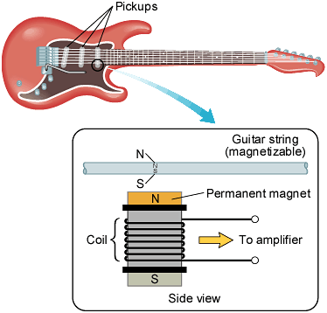
Year 11 Circuits Revision
- Three resistors of 12 Ω, 16 Ω and 8 Ω are connected in series and a 12V potential difference is applied across the combination.
- What is the total resistance?
- What current flows?
- What is the potential difference across the 8 Ω resistor?

- A battery, supplying a potential difference of 12.0 V is connected to two resistors 5 Ω and 20 Ω connected in parallel.
- What is the combined resistance?
- What total current flows in the circuit?
- What is the current in the 20 Ω resistor?

- A toaster and a kettle connected in parallel have 240V mains potential difference applied across them. The current in the toaster is 2A and the current in the kettle is 5A. Calculate:
- The resistance of the toaster
- The resistance of the kettle
- The total current flowing.

- An 8 Ω resistor and a 2 Ω resistor are connected in parallel. This combination is connected in series with a 2.4 Ω resistor and a 6 V battery.
- What is the total resistance?
- What current flows in the 2.4 Ω resistor?
- What is the potential difference across the parallel combination?
- What current flows in the 8 Ω resistor?

- Three cells, each with an emf of 2.2V are in series. The battery is connected in series with a switch S, an ammeter, a resistor of 1.8 Ω and a combination of two parallel connected resistors of 2 Ω and 3 Ω respectively. Voltmeters V₁ and V₂ are connected across the battery terminals and across the parallel resistors respectively.
- Draw the circuit diagram.
- What are the readings on A, V₁ and V₂ when S is open?
- Determine the equivalent resistance of the parallel combination of resistors.
- What will be the readings on A, V₁ and V₂ when S is closed?
- How much energy is consumed by the 1.8 Ω resistor in 1 minute?

- In the circuit below the 12 V battery and meters have negligible resistance. Voltmeter V₁ reads 9V. R is a resistor of unknown resistance.
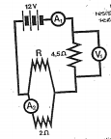
Calculate:
- The reading on ammeter A₁.
- The reading on ammeter A₂.
- The resistance of R.
- The energy transferred in the 4.5 Ω resistor in 1 minute.

- A lamp operates on a 100 V supply and draws a current of 0.50 A. What resistor must be placed in series if it is to be used on a 230 V supply.
- Calculate the current in the 2 ohm resistor.
1.0 ohm
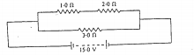
15.0 V
3.0 ohm
2.0 ohm

- The three resistors of 4.0 Ω, 8.0 Ω and 40.0 Ω are connected in parallel. The 4.0 Ω resistor carries a current of 2A. Calculate:
- The combined resistance
- The potential difference across the parallel branch.
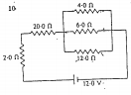
- The current in the 8.0 Ω and 40.0 Ω resistors.
4.0 ohm

6.0 ohm ohmohm
20.0 ohm

2.0 ohm
12.0 ohm

12.0 V

- The diagram shows resistances joined in parallel and series.
- What is the equivalent resistance of the circuit?
- What current flows through the 20 Ω resistor?
- What is the potential difference across the 2 Ω resistor?
- What is the potential difference across the 4.0 Ω resistor?
- What is the current flowing through the 4.0 Ω resistor?

Answers:
- a) 36 Ω b) 0.33A c) 2.67V
- a) 4 Ω b) 3A c) 0.6A
- a) 120 Ω b) 48 Ω c) 7A
- a) 4 Ω b) 1.5 Ω c) 2.4V d) 0.3 A
- b) 0A 6.6V 0V c) 1.2 ohm d) 2.2A, 6.6 V , 2.64V A e) 523J
- a) 2A b) 1.5A c0 6 Ω d) 1080 J
- 260 Ω
- 5A
- a) 2.5 Ω b) 8V c) 1A and 0.2A
- a) 24 Ω b) 0.5A c) 1V d) 1V e) 0.25A
- a) V_{AB} 12V b) I_{AB} = 0.3 A c) I = 0.2A
- R = 8 ohm.

Bibliography
(n.d.). Retrieved from Slide player: http://slideplayer.com/slide/4442442/
bibliotecapleyades.net. (n.d.). Retrieved from Tesla coil: http://www.bibliotecapleyades.net/imagenes_tesla/tesla17_02.gif
Hyperphysics. (2019, November 28). Retrieved from Magnetic field of the Earth: http://hyperphysics.phy-astr.gsu.edu/hbase/magnetic/MagEarth.html
Thermometer Clip Art - Image #8708. (n.d.). Retrieved from Clip art: http://cliparting.com/free-thermometer-clip-art-8708/

